# Overview

This document contains the necessary information to build the Redwood Joystick, a robust analog USB joystick that can be used for digital access or adaptive gaming. The Maker Checklist outlines the required steps, including questions for the User. The Tool List contains a comprehensive list of tools and supplies required to complete the build. The 3D Printing Guide contains print settings and quantities for the 3d printed components. The Assembly Guide contains all the necessary steps to assemble and program the device. Finally, the Testing Guide contains a set of tests to confirm the Redwood Joystick works properly.

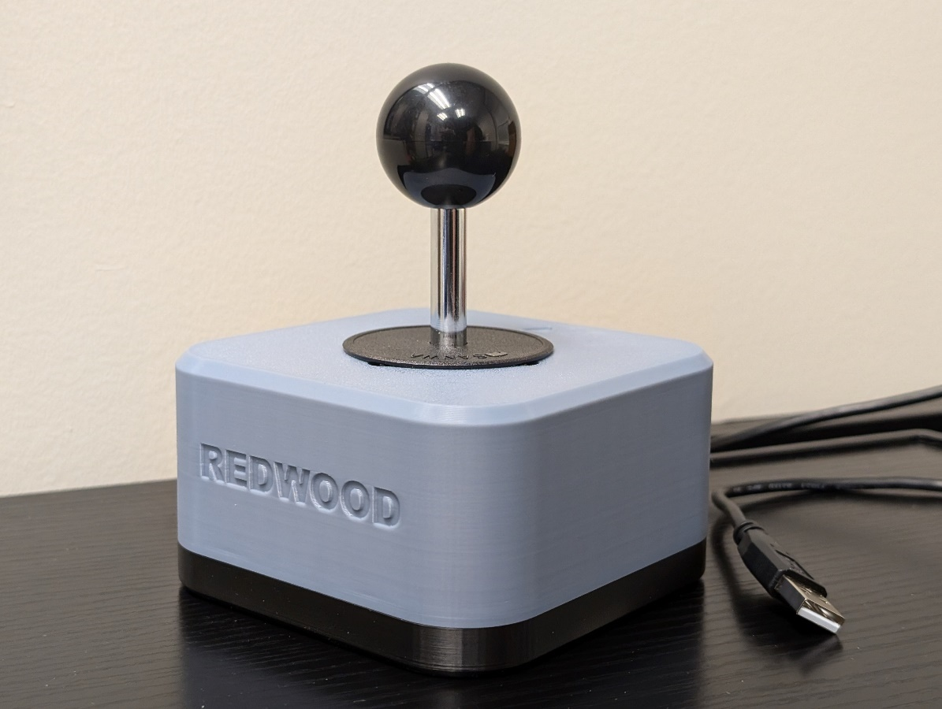

Contents

Overview 1

Maker Checklist 3

Maker To Do List 3

Items to Give to User 3

Tool List 5

Tools / Equipment 5

Supplies 5

Personal Protective Equipment (PPE) 5

Customization Guide 6

3D Printing Guide 7

3D Printing Summary 7

3D Printing Settings 7

Post-Processing 7

Maker Component List 9

Assembly Guide 10

Part A: Enclosure 11

Part A: Required Components 11

Part A: Required Tools and Supplies 11

Part A: Required Personal Protective Equipment (PPE) 11

Part A: Enclosure Assembly Steps 12

Part B: Topper and Mounting Adapters (OPTIONAL) 18

Part B: Required Components 18

Part B: Required Tools and Supplies 18

Part B: Required Personal Protective Equipment (PPE) 18

Part B: Topper Adapter Assembly Steps 19

Part C: Mounting Adapters (OPTIONAL) 20

Part C: Required Components 20

Part C: Mounting Adapter Steps 20

Testing 23

Troubleshooting 23

# Maker Checklist

This list provides an overview of the steps required to build and deliver the Redwood Joystick

## Maker To Do List

* Read through the Maker Guide to become familiar with required components, tools, supplies, safety gear, and overall assembly steps.
* Talk to the User about customization options
  + Color of prints:
    - Can customize the top and/or bottom enclosure.
    - Topper colors can also be customized if toppers are requested.
  + Topper sizing:
    - The toper adapter allows the [Oak Toppers](https://github.com/makersmakingchange/Oak-Compact-Joystick/tree/main/Build_Files/3D_Printing_Files/Toppers) to be compatible. There is a default small, medium, and large size of toppers. There is also a [topper sizing guide](https://github.com/makersmakingchange/Oak-Compact-Joystick/blob/main/Documentation/Oak_Joystick_Topper_Guide.pdf) that you can send to the user to see which size and shape they would prefer.
  + Mounting options:
    - There are [RAM and ¼-20 mounting adapters available from the Oak joystick](https://github.com/makersmakingchange/Oak-Compact-Joystick/tree/main/Build_Files/3D_Printing_Files/Toppers) as well that will fit.
    - Ask the user which way they would like to mount the joystick.
      * Tabletop – ask if hook and loop should be added to the bottom
      * Mounting arm – ask if it has a ¼-20 thread or a RAM attachment (confirm it is RAM type B [1-inch] Compatible)
  + How they would like to receive the “User Guide” (PDF or physical copy)
* Order hardware components
* Gather tools, supplies, and safety equipment.
* Assemble the device
* Test the Redwood Joystick
* Print “User Guide” (if the User would like a physical copy)

## Items to Give to User

* Assembled Redwood Joystick
  + Optional:
    - Topper adapter if they want to use any Oak toppers.
    - Oak toppers they may want.
* User Guide

# Tool List

## Tools / Equipment

|  |  |  |  |
| --- | --- | --- | --- |
| Tool ID | Description | Required / Recommended | Notes |
| T01 | Philips screw driver | Required | Tighten/loosen Philips head fasteners |
| T02 | 3D printer | Required | Printing the enclosure/possible toppers and adapters |
| T03 | Canadian Small Coin (Dime) | Recommended | If using a topper adapter, it helps spin the adapter cover. Any small coin will work. |
| T04 | Flush Cutters | Recommended | Cutting the cable tie. Scissors or other cutting tools may work. |

## Supplies

|  |  |  |  |  |
| --- | --- | --- | --- | --- |
| Supplies ID | Description | Quantity | | Notes |
| S01 | Filament | 150g |  | |

## Personal Protective Equipment (PPE)

|  |  |  |
| --- | --- | --- |
| PPE ID | Description | Notes |
| P01 | Safety Glasses | When cutting the cable tie, wear safety glasses to prevent debris entering your eyes. |

# Customization Guide

The device can be printed in the user’s desired colour. As a suggestion, the bottom and top enclosure can be matching or different colors depending on the users preference.

# 3D Printing Guide

The device was originally printed on a Bambu P1S using the Bambu Studio slicer.

## 3D Printing Summary

|  |  |
| --- | --- |
| **Metrics** | **Single Unit** |
| Total Print Time (hour min) | 3h 2m |
| Total Number of Components | 2 |
| Typical Total Mass (g) | 139.01 |
| Typical Number of Print Setups | 1 |

## 3D Printing Settings

Note that the 3D printing material should be assumed to be PLA unless otherwise noted in the table below.

|  |  |  |  |  |  |  |  |
| --- | --- | --- | --- | --- | --- | --- | --- |
| **Print File Name** | **Qty** | **Total Print Time (hr:min)** | **Mass (g)** | **Infill (%)** | **Support(Y/N)** | **Layer Height/ Nozzle Diameter(mm)** | **Notes** |
| Redwood-Joystick-Enclosure-Base-v1.0 | 1 | 1:10 | 46.15 | 15 | N | 0.20/0.4 | **Print with 4 Wall Loops for increased strength** |
| Redwood-Joystick-Enclosure-Top-v1.0 | 1 | 1:58 | 92.84 | 15 | N | 0.20/0.4 | **Print with 4 Wall Loops for increased strength** |
| Redwood-Joystick-Topper-Adapter-Cover-v1.0 | 1 | 0:7 | 0.34 | 15 | N | 0.20/0.4 | **OPTIONAL** |
| Redwood-Joystick-Topper-Adapter-Nut-v1.0 | 1 | 0:19 | 4.87 | 15 | N | 0.20/0.4 | **OPTIONAL** |

## Post-Processing

Inspect the 3D printed parts for any printing defects, sharp edges, or burrs. Sharp edges and burrs can be removed with sanding or deburring tools. Examples of Quality Prints

Compare your 3D prints to the images here. If there are significant differences, you may need to reprint the part.

|  |  |
| --- | --- |
| Enclosure | |
| Redwood-Joystick-Enclosure-Base-v1.0 | **Redwood-Joystick-Enclosure-Top-v1.0** |
| inside of bottom caseoutside of bottom of case | inside of top case  outside of top case |

|  |  |
| --- | --- |
| Optional: Topper Adapter | |
| Redwood-Joystick-Topper-Adapter-Nut-v1.0 | **Redwood-Joystick-Topper-Adapter-Cover-v1.0** |
| top down view of adapter nut | top down view of topper adapter cover |

# Maker Component List

|  |  |  |  |  |  |  |  |  |
| --- | --- | --- | --- | --- | --- | --- | --- | --- |
| Enclosure | | | | | | | | |
| A01 | Screw, #4 self-tapping 3/8" length | QTY: 4 | A02 | UltraStik 360 Joystick Component | QTY: 1 | A03 | Hex nut, M3 | QTY: 2 |
| 4 screws | | | ultrastik, ball topper, dust coverusb cable  (joystick component, dust cover, ball top, USB cable) | | | two hex nuts | | |
| A04 | Cable tie, 4" | QTY: 1 | A05 | Enclosure Base | QTY: 1 | A06 | Enclosure Top | QTY: 1 |
| cable tie | | | bottom enclosure | | | top enclosure | | |

|  |  |  |  |  |  |  |  |  |  |  |  |  |  |  |  |  |  |  |  |
| --- | --- | --- | --- | --- | --- | --- | --- | --- | --- | --- | --- | --- | --- | --- | --- | --- | --- | --- | --- |
| *Optional: Topper and Mounting Adapters | | | | | | | | | | | | | | | | | | | |
| B01 | | Metric Hex Nut M6-1.00 | | QTY: 1 | | B02 | | | Topper Adapter Nut | QTY: 1 | | | B03 | | | Topper Adapter Cover | | QTY: 1 | |
| one hex nut | | | | | | topper adapter nut | | | | | | | topper adapter cover | | | | | | |
| B04 | RAM Mount Adapter | | QTY: 1 | | B05 | | | Camera Mount Adapter | | | | QTY: 1 | | B06 | | | M3x12mm Screw | | QTY: 2 | |
|  | | | | |  | | | | | | | | |  | | | | | | |
| B07 | 1/4″-20 UNC Tee Nut Insert, 5/16″ Length | | QTY: 1 | | B08 | | 1/4″-20 Bolt (Any length greater than 10 mm) | | | | QTY: 1 | | |
|  | | | | |  | | | | | | | | | |

# Assembly Guide

|  |  |
| --- | --- |
| Assembly Section | |
| Part A: Enclosure |  |
| OPTIONAL Part B: Topper Adapter | assembled topper adapter |
| OPTIONAL Part C: Mounting Adapters |  |

## Part A: Enclosure

### Part A: Required Components

|  |  |  |  |  |  |  |  |  |
| --- | --- | --- | --- | --- | --- | --- | --- | --- |
| Enclosure | | | | | | | | |
| A01 | Screw, #4 self-tapping 3/8" length | QTY: 4 | A02 | UltraStik 360 Joystick Component | QTY: 1 | A03 | Hex nut, M3 | QTY: 2 |
| 4 screws | | | ultrastik, ball topper, dust coverUSB type A to USB micro  (joystick component, dust cover, ball top, USB cable) | | | two hex nuts | | |
| A04 | Cable tie, 4" | QTY: 1 | A05 | Enclosure Base | QTY: 1 | A06 | Enclosure Top | QTY: 1 |
| cable tie | | | enclosure base | | | enclosure top | | |

### Part A: Required Tools and Supplies

* Philips Screw Driver
* 3D printer
* Flush cutters

### Part A: Required Personal Protective Equipment (PPE)

* Safety Glasses

### Part A: Enclosure Assembly Steps

#### Step A-01: Insert M3 Nuts

Take the enclosure base and locate the two nut catches. Take the 2 M3 hex nuts and insert them into these catches. It is recommended to line them up in the slot and then use the screwdriver to push the hex nuts inside the catches.

|  |  |
| --- | --- |
|  |  |
|  | |

#### Step A-02: Remove Mounting Plate from Ultrastik Joystick Component

Take the Ultrastik Joystick component and remove the 4 screws connecting the silver mounting plate to the rest of the joystick. **KEEP the 4 screws you removed in a safe place, you will need them for the next step**. You can disregard the mounting plate for the rest of the build.

|  |  |
| --- | --- |
|  |  |

#### Step A-03: Placing Joystick to Top Enclosure

Take the top enclosure and place the Ultrastik Joystick component inside with the USB port on the joystick component in the corner with the text on the inside of the top enclosure that says “USB GOES HERE”. This must be aligned to ensure proper directionality of the joystick.

|  |  |
| --- | --- |
|  |  |

#### Step A-04: Attaching Joystick to Top Enclosure

Take the 4 screws that you removed in Step 2 and insert them into the holes on the outer top of the top enclosure. Use the Philips Screwdriver to screw them through the top enclosure and into the Ultrastik Joystick component.

Make sure that the screws are sunken into the top of the housing. Approx 1 mm.

|  |  |
| --- | --- |
|  |  |
|  | |

#### Step A-05: Attaching the USB Cable

Take the USB cable and attach it to the USB port on the Ultrastik Joystick component. Take the cable tie and pass it through the strain relief feature and attach the USB cable to the side of it. Tighten down the cable tie and use the flush cutters to cut off the excess.

|  |  |
| --- | --- |
|  |  |
|  | |

#### Step A-06: Attaching the Bottom Enclosure

Take the bottom enclosure component and fit it to the top component with the cable exit lining up. Take the 4 #4 screws and screw them into the 4 holes on the bottom of the bottom enclosure. Tighten until snug.

|  |  |
| --- | --- |
|  |  |
|  | |

#### Step A-07: Add the Dust Cover and Ball Topper

Take the dust cover and ball topper from the Ultrastik and add them to the joystick. Place the dust cover on first and then thread on the ball topper.

|  |  |
| --- | --- |
|  |  |
|  | |

## Part B: Topper and Mounting Adapters (OPTIONAL)

**This section is only needed if the user wants to use Oak Joystick toppers on with the Redwood.**

### Part B: Required Components

|  |  |  |  |  |  |  |  |  |
| --- | --- | --- | --- | --- | --- | --- | --- | --- |
| B01 | Metric Hex Nut M6-1.00 | QTY: 1 | B02 | Topper Adapter Nut | QTY: 1 | B03 | Topper Adapter Cover | QTY: 1 |
|  | | |  | | |  | | |

### Part B: Required Tools and Supplies

* Philips screw driver
* 3D printer
* **Optional:** Canadian small coin (dime)

### Part B: Required Personal Protective Equipment (PPE)

* None

### Part B: Topper Adapter Assembly Steps

#### Step B -01: Insert M6 Nut

Take the Topper Adapter Nut 3D print and place it on the table with the thread side facing up. Place the M6 nut into the top of the Topper Adapter Nut. Make sure to line it up so the M6 nut sits flush inside.

|  |  |
| --- | --- |
|  |  |

#### Step B -02: Add Topper Adapter Cover

Take the Topper Adapter Cover and place it on top of the M6 nut with the slot side facing up. Line up the three stubs on the Topper Adapter Nut with the three cutouts on the Topper Adapter cover.

|  |  |
| --- | --- |
|  |  |

#### Step B -03: Secure M6 Nut

Use a small coin, screwdriver, or any tool you can use to rotate the Topper Adapter Cover so then the three stubs and cutouts are not lined up. This will lock in the M6 Nut making it easier to screw onto the Ultrastik joystick.

|  |  |
| --- | --- |
|  |  |

You can now easily screw this onto the Ultrastik joystick threaded stick.

## Part C: Mounting Adapters (OPTIONAL)

**This section is only needed if the user wants to connect the Redwood to a 1/4 -20 camera mount or 1 inch RAM mount.**

If the joystick needs to be mounted on a RAM style or ¼-20 camera mount, please assemble one of the adapters. The **RAM mount adapter DOES NOT NEED** the tee nut insert or ¼-20 bolt.

### Part C: Required Components

|  |  |  |  |  |  |  |  |  |  |  |  |
| --- | --- | --- | --- | --- | --- | --- | --- | --- | --- | --- | --- |
| B04 | RAM Mount Adapter | QTY: 1 | B05 | | Camera Mount Adapter | | QTY: 1 | B06 | | M3x12mm Screw | QTY: 2 |
|  | | |  | | | | |  | | | |
| B07 | 1/4″-20 UNC Tee Nut Insert, 5/16″ Length | QTY: 1 | B08 | 1/4″-20 Bolt (Any length greater than 10 mm) | | QTY: 1 | |
|  | | |  | | | | | |

### Part C: Required Tools and Supplies

* Plyers to tighten down ¼-20 bolt.
* 3D printer
* Flush cutters to remove any excess filament

### Part C: Required Personal Protective Equipment (PPE)

* Safety Glasses

### Part C: Mounting Adapter Steps

#### Camera Mount Assembly

|  |  |
| --- | --- |
| Step 1: Prepare and Orient 3D Print Flip the camera mount adapter around to reveal the recess with small slots.  Ensure all supports are removed from the 3D print. | Blue 3D printed part for the camera mount adapter. There are two holes on the sides and one hole in the middle with small slots around it. |

|  |  |
| --- | --- |
| Step 2: Insert Tee Nut Insert the tee nut, lining up the barbs with the small slots in the 3D print. | Blue 3D printed part for the camera mount adapter, with a tee nut sitting inside of it, not fully inserted. |

|  |  |
| --- | --- |
| Step 3: Screw in Bolt Flip the part around and screw in a ¼-20 hex bolt. | Blue 3D printed part for the camera mount adapter, with a hex bolt being screwed into it. There is a white arrow showing to screw in the hex bolt clockwise. |

|  |  |
| --- | --- |
| Step 4: Tighten Bolt Tighten the bolt until the tee nut is seated down as far as possible.  (Alternatively, if you do not have acces to a bolt, the tee nut may be press fit as long as it sits flush with the 3D print.) | Top of the camera mount adapter, with a hex bolt fully screwed into it. There is a white arrow showing to screw in the hex bolt clockwise. Bottom of the camera mount adapter, showing a tee nut fully installed into the 3D print, and sitting flush. There are two arrows pointing down to indicate that the tee nut is all the way down. |

|  |  |
| --- | --- |
| Step 5: Attach to Joystick Using 2 M3 screws, screw the camera mount adapter to the bottom of the joystick in the two middle holes. |  |

#### RAM Mount Assembly

|  |  |
| --- | --- |
| Step 1: Attach to Joystick Using 2 M3 screws, screw the RAM mount adapter to the bottom of the joystick in the two middle holes. |  |

# Testing

You can test using an Xbox Adaptive controller or plugging directly into a PC.

1. Plug the joystick into the analog joystick input for the host device.
   1. X1 or X2 on an Xbox Adaptive Controller.
2. Plug the host device into a computer.
3. If using Windows, open “Set up USB Game Controllers” from the Control Panel. You can find this by searching your computer in the search bar next to the Windows icon.
   1. If using a Mac, use <https://hardwaretester.com/gamepad>
4. Select the host device from the list of controllers and go to “Properties”.
5. Move your joystick and observe the movement of the cross hatch in the “Axes” window. Ensure it moves in the proper directions when you move the joystick (the arrow points in the up direction). If not, open the joystick and check your connections.

# Troubleshooting

If your joystick is not moving in the same directions as expected, make sure you have the proper alignment shown in Step A-03: Placing Joystick to Top Enclosure.